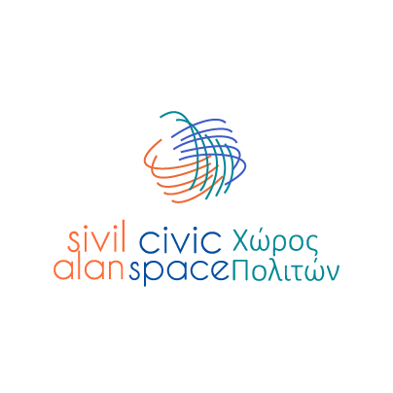

Grow Civic – Civic Space

Annex 1 – Request for Support Form

Grow Civic provides flexible and primarily in-kind support for civic initiatives and community-based actions through operational services, expert support, technical assistance, and, where justified, limited operational support.

Please complete all relevant sections. Where a section does not apply, indicate 'N/A'. Fields marked with a maximum word/page count should be respected.

This is not a grant application. Grow Civic does not generally provide direct financial transfers to applicants.

REQUEST FOR SUPPORT FORM

Section 1: Applicant Information

1.1 Applicant Name / Organisation
(Name of the organisation, group, or individual applying)

1.2 Type of Applicant
☐ Civil Society Organisation (CSO)
☐ Informal Group / Civic Initiative
☐ Individual Activist
☐ Media actor
☐ Cooperative
☐ Trade union / professional association
☐ Other (please specify): ___________

1.3 Contact Person
(Name and position, if applicable)

1.4 Contact Details
Email:
Phone:

1.5 Area of Implementation
(Where will the support be implemented? e.g. city / region)

1.6 When is the support needed?
☐ As soon as possible
☐ Within 1 month
☐ Within 2–3 months
☐ Specific date / event deadline
☐ Other (please specify): ___________

1.7 About the Applicant
Please briefly describe your organisation, group, or initiative, and any relevant experience related to this request. (max 100–120 words)

Section 2: The Issue to be Addressed
2.1 Please describe the issue or challenge you would like to address.
What is happening? Who is affected? Why is this issue relevant for the community or target groups? You may refer to the situation, key challenges, affected groups, or recent developments. (max 150–200 words)

Section 3: Proposed Action
3.1 What would you like to do?
Please describe the action or initiative you are proposing. (max 150–200 words)

3.2 Main activities
(For example: awareness activity, research, campaign, event, advocacy action, etc.)
Activity | Short description
Activity 1
Activity 2
Activity 3

3.3 Estimated duration of the action
☐ One-off activity
☐ Up to 1 month
☐ 1–3 months
☐ 3–6 months

Section 4: Why is this needed now?
Please explain why this support is needed at this moment. (Is there a specific opportunity, deadline, or urgent issue?) (max 100 words)

Section 5: Expected Results
What do you expect this action to achieve? (max 100–150 words)

Section 6: Who will benefit?
Please describe target groups, how the project will reach them and how they will benefit.

Target groups | How will they benefit? | Approximate number

Section 7: What support do you need from Grow Civic?

7.1 Requested Services (if applicable)
Type of Service Requested | Short Description | Suggested Provider (optional) | Estimated Operational Value (EUR)

7.2 Expert Support (if applicable)
Type of Expertise Required | Tasks to be Performed | Suggested Expert (optional) | Estimated Working Days

7.3 Exceptional Operational Support Needs (if applicable)
This section should only be completed where the requested operational needs cannot reasonably be addressed through direct service provision or expert support.
Item | Explanation | Estimated Operational Value (EUR)

7.4 If you suggest a provider or expert outside the Grow Civic pool, please briefly explain why.

Section 8: Risks or Sensitivities (optional)
Please indicate any operational, safeguarding, accessibility, security, conflict-sensitivity, or reputational considerations relevant to the proposed action. (max 100–150 words)

Section 9: Partners (if applicable)
Please briefly describe any partners involved and their role. (max 100 words)

Section 10: Declaration
By submitting this request, I confirm that the information provided is accurate and that the support requested will be used for the purposes described above.

I understand that Grow Civic support is primarily provided through in-kind operational and technical assistance coordinated by the Civic Space project.

Name
Date
Signature

Processing of Requests
Requests are reviewed on a rolling basis.

As a general guideline:
• Requests requiring support of up to EUR 5,000 are typically processed within approximately 2 weeks.
• Requests requiring higher levels of support (up to EUR 15,000) may require additional review time and are typically processed within up to 4 weeks.

Actual processing time may vary depending on the complexity of the request and the need for clarifications.

Particular consideration may be given to requests addressing urgent or time-sensitive needs.

