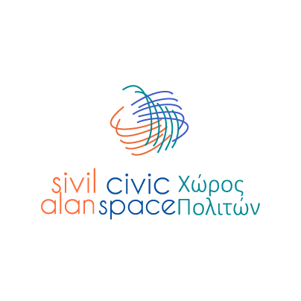

Grow Civic – Civic Space

Annex 4
Grow Civic – Support Agreement Template
This Agreement defines the collaboration and implementation arrangements between the Civic Space project and the beneficiary of support provided under the Grow Civic facility.
The purpose of this Agreement is to clarify the scope of support, implementation arrangements, responsibilities of the parties, and visibility obligations related to the approved action.
This Agreement does not constitute a grant contract and does not establish entitlement to direct financial transfers.
GROW CIVIC SUPPORT AGREEMENT
Agreement Reference Number
_________________________
Date of Signature
_________________________

1. PARTIES TO THE AGREEMENT
The Civic Space Project
Implemented by GFA Consulting Group under the European Union Aid Programme for the Turkish Cypriot community.
Represented by:
Name: _________________________
Position: _________________________
AND
Beneficiary / Supported Initiative
Name of organisation / initiative: _________________________
Represented by:
Name: _________________________
Position (if applicable): _________________________
Address / Contact Details: _________________________

2. TITLE OF THE SUPPORTED ACTION
__________________________________________________

3. PURPOSE OF THE SUPPORT
The purpose of this Agreement is to support the implementation of the approved civic initiative and/or community-based action under the Grow Civic facility.

4. IMPLEMENTATION PERIOD
Start Date | End Date

5. DESCRIPTION OF APPROVED SUPPORT
5.1 Support under this Agreement will be provided in accordance with:
• the approved Grow Civic Request for Support Form;
• any approved Detailed Request for Services and/or Expert Support;
• and any subsequent implementation arrangements agreed between the beneficiary and the Civic Space project.
5.2 The support may include operational services, expert support, technical assistance, logistical support, and other implementation-related assistance necessary for the implementation of the approved action.
5.3 Implementation arrangements may be adjusted during implementation where necessary for operational, procurement, visibility, financial, compliance, or logistical reasons.

6. RESPONSIBILITIES OF THE CIVIC SPACE PROJECT
The Civic Space project will:
• coordinate approved support arrangements;
• mobilise and coordinate relevant service providers and/or experts where applicable;
• provide operational guidance related to implementation;
• support visibility and communication compliance where relevant;
• maintain communication with the beneficiary regarding implementation progress and arrangements.

7. RESPONSIBILITIES OF THE BENEFICIARY
The beneficiary agrees to:
• implement the supported action in accordance with the agreed arrangements and the Grow Civic guidelines and procedures;
• cooperate with the Civic Space team, service providers, and experts involved in implementation;
• use the provided support solely for the agreed action and purposes;
• inform the Civic Space project about significant changes, delays, risks, or implementation challenges;
• comply with applicable visibility and communication requirements;
• provide brief narrative updates or final summaries where requested.

8. VISIBILITY AND COMMUNICATION
The beneficiary agrees to acknowledge the support of the European Union and the Civic Space project in relevant communication and visibility activities related to the supported action.
Additional requirements are described in the Grow Civic Visibility Guidelines.

9. ETHICAL PRINCIPLES
The beneficiary agrees to implement the supported action in a respectful, inclusive, and non-discriminatory manner and in line with the principles and values of the Grow Civic facility and the European Union.

10. MODIFICATIONS
Any significant modifications related to implementation arrangements, timelines, activities, or operational support should be communicated to the Civic Space project as early as possible.

11. FINAL PROVISIONS
This Agreement reflects the operational arrangements for support provided under the Grow Civic facility and does not create a grant beneficiary relationship between the parties.
This Agreement enters into effect upon signature by both parties.

SIGNATURES
For the Civic Space Project
Name / Position
Signature
Date
For the Beneficiary / Supported Initiative
Name / Position
Signature
Date

